**CECS 4202_80_81 Database Systems**

**WINTER 2024**

**Books**

*Database Systems: Design, Implementation, & Management (2016)*

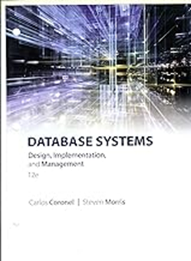by Carlos Coronel and Steven Morris

12th Edition

Cengage Learning

ISBN-10: ‎ 1305627482

ISBN-13: ‎ 978-1305627482

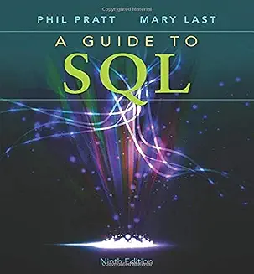

*A Guide to SQL (2014)*by Philip J. Pratt and Mary Z. Last

Course Technology; 9th edition

ISBN: 978-1111527273